Conceptual Design
Class Petitioner

Major Features
- Class Section Petition Creation
- Signing a petition of your peers
- Browsing to see what classes are most desired(signed the most)
- Automatic notification of faculty and students
- Allows faculty to see how many people actually still want to take the class
- Allows students to see the likeliness of a new section

Major Modules
- Personal class portal to see what you have signed (uses user database)
- Ability to search open petitions (uses petition database)
- Emailing system to email faculty and students about petition statuses
(uses user database)
- Automated website scraping to get full class information for potential petition creation
(feeds information to the petition database)
- Petition Database
- User Database

Functional Requirements

- The system must allow students to create, sign, unsign, and search for petitions
- The system must email faculty and students appropriately to keep them informed of a potential new section or if the petition has been closed and why
- The system must have a portal for faculty and a portal for students with their own separate functionality
- The system will self manage petitions and their status and notify students and faculty based on their settings
- The system must have an authentication login for students and faculty
- The system will house user profiles with information only needed for signing petitions

Non-functional Requirements

- When a new petition is made the faculty involved, and students possibly interested shall be notified
- A personalized portal will appear after login to show a persons submitted petitions or those signed and a brief description of the status
- Browsing petitions is the only action that will be allowed by the system without an account
- The petitions will have comment boards so people can discuss their experiences
- System will automatically scrape the SJSU website for full classes, and offer them as petition choices

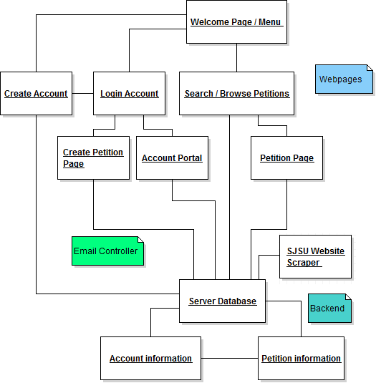

Use case example : Account Creation
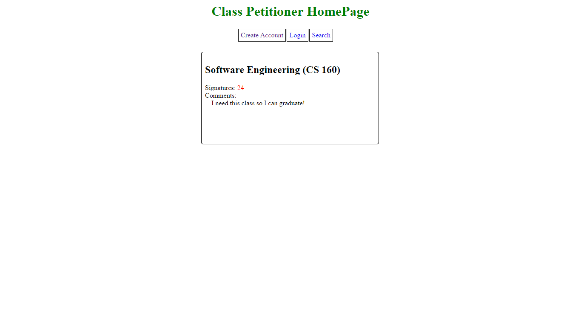
Here the user would click on ‘Create Account’
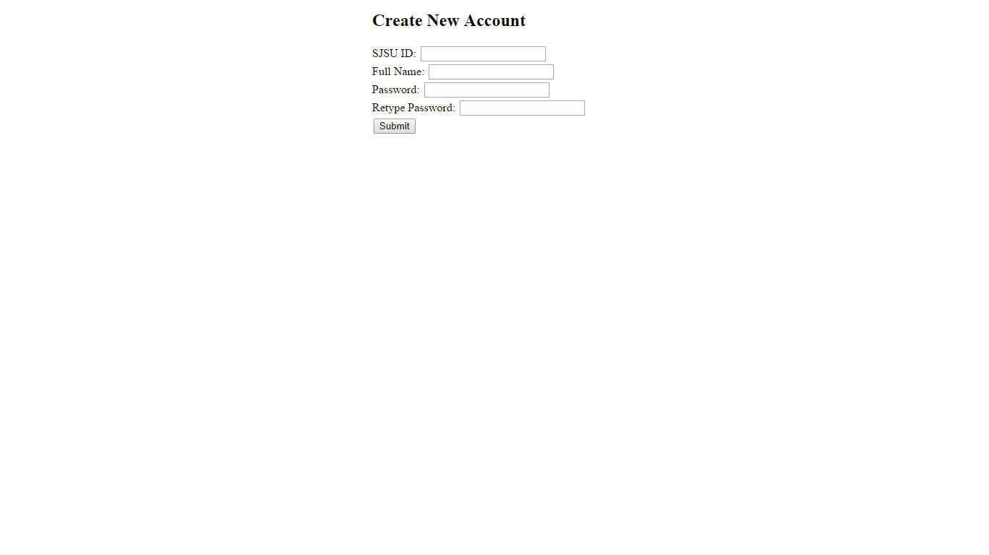Here the user fills out the required information and submits it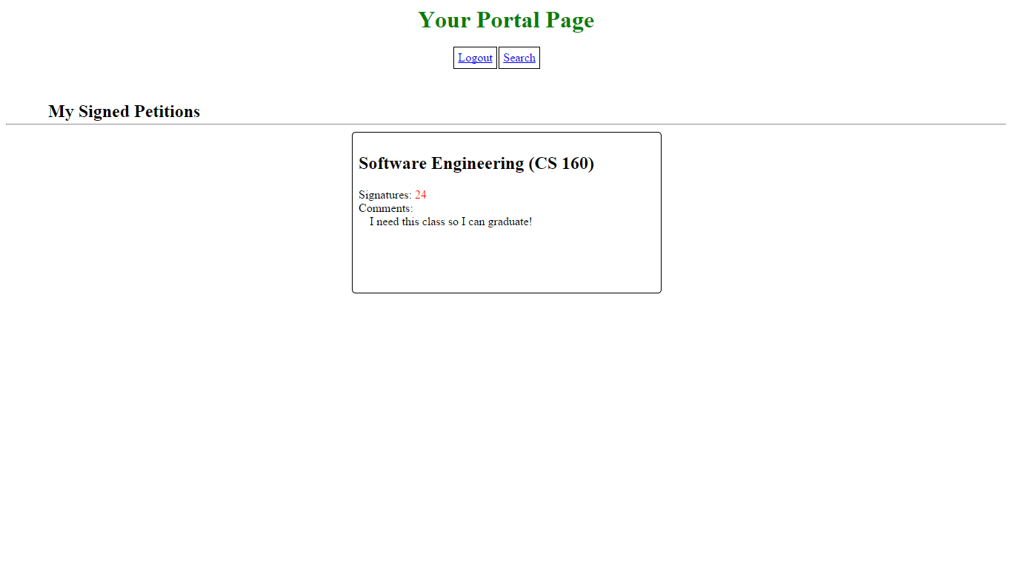
This is the final page, this is what the user sees once they have logged in.

